**Photo voltaic E-Uniform with Peltier plate thermo cool technology for soldiers who work at extreme high temperature or extreme low temperature to warm up or cool down body temperature**

# CHAPTER 1

**1.1 ABSTRACT:**

Solar power is energy from the sun that is converted into thermal or electrical energy. Solar technologies can harness this energy for a variety of uses, including generating electricity, providing light or comfortable interior environment, and heating for domestic, commercial or industrial use. There are three main ways to harness solar energy: photovoltaics, solar heating and cooling and concentrating solar power. Photovoltaics generate electricity directly from sunlight through electronic process and can be used to power anything from small electronics such as calculators and rad signals and large commercial businesses. Solar gadgets play an important role in numerous real-life applications, such as whenever a person go outdoors it is essential to ensure that person should be protected against any weather conditions there might be out there. Excessive exposure to heat is referred to as heat stress and excessive exposure to cold is referred to as cold stress. In a very hot environment, the most serious concern is heat stroke. At very cold temperatures, the most serious concern is the risk of hypothermia or dangerous overcooling of the body, so design of an E-Jacket which gives better protection people live in extreme weather conditions. This jacket maintains the desired temperature inside the jacket.

**1.2 OBJECTIVES:**

## The aim of the project “Photo voltaic E-Uniform with Peltier plate thermo cool technology for soldiers who work at extreme high temperature or extreme low temperature to warm up or cool down body temperature” is:

## To utilize the solar energy in most wild.

## Integrating the energy source with functional conductors and conducting elements with the garment.

## To provide thermal comfort to user against extreme climatic conditions.

## This project is aimed at finding a variable charging station.

# CHAPTER 2

### 2.1 LITERATURE SURVEY:

There are many solar based garments which were invented some of them are: Tommy Hilfiger launches solar power jackets to charge your phone. The clothing label has developed a range of clothing embedded with solar panels so that you always have backup power for your devices. Over the past ten years, photovoltaic power generation has grown rapidly worldwide, and is starting to contribute a noticeable amount of electricity production to public grids, especially in Japan and Germany. Electric energy from solar cells is still too expensive to compete with established power plants, but photovoltaic island systems3 located far connection have been economically successful for many years systems varies over a considerable range from several kilowatts to less than one watt. They have a common layout comprising storage batteries and power conditioning electronics, as well as the solar modules themselves.

1. Excessive exposure to heat is referred to as heat stress and excessive exposure to cold is referred to as cold stress.
2. In a very hot temperatures, the most serious concern is heat stroke and at very cold temperatures, there is risk of hypothermia or dangerous overcooling of the body.
3. There is a chance that the person can be lost in snow or desert, so tracking them is difficult.

### WORKING PRINCIPLE:

A Smart Heating Jacket that utilizes Peltier modules operates on the principle of the Peltier effect, which is a thermoelectric phenomenon. Peltier modules, also known as thermoelectric can both heat and cool surfaces by manipulating the flow of electrical current through them. Here's a detailed explanation of the working principle of such a jacket:

**Peltier Modules:** Peltier modules consist of two semiconductor materials with different electrical properties sandwiched between two ceramic plates. One side of the module is the hot side, and the other is the cold side. When a direct current (DC) voltage is applied to the module, it causes electrons to move from the hot side to the cold side. This electron movement carries heat energy with it, creating a cooling effect on the cold side and a heating effect on the hot side simultaneously.

**The thermoelectric effect** is the direct conversion of temperature differences to electric voltage and vice versa via a thermocouple. A thermoelectric device creates a voltage when there is a different temperature on each side.

**Note that, In our design, the Peltier modules in the jacket must be turned over if the soldier wishes to feel warm in the cooler temperatures.**

### 2.2 BLOCK DIAGRAM:

**TEMPERATURE SENSOR**

**MOSFET**

**(For safe protection)**

**12v BATTERY**

**ARDUINO UNO**

**PELTIER MODULE**

**LCD DISPLAY**

### 2.3 DESCRPTION OF EACH BLOCKDIAGRAM

1. **ARDUINO(UNO)**:

The ARDUINO microcontroller is an easy to use yet powerful single board computer that has gained considerable traction in the hobby and professional market. The ARDUINO is open source, which means hardware is reasonably priced and development software is free. The ARDUINO project was started in Italy to develop low cost hardware for interaction design. It has 14 digital input/output pins (of which 6 can be used as PWM outputs), 6 analog inputs, a 16 MHz quartz crystal, a USB connection, a power jack, an ICSP header and a reset button. Arduino consists of both a physical programmable circuit board (often referred to as a microcontroller) and a piece of software, or IDE (Integrated Development Environment) that runs on your computer, used to write and upload computer code to the physical board.

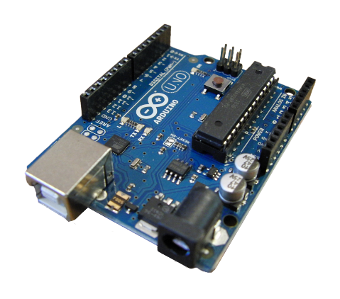

1. **SINGLE CHANNEL RELAY:**

A relay is an electrically operated device. It has a control system and (also called input circuit or input contactor) and controlled system (also called output circuit). It is frequently used in automatic control circuit. To put it simply, it is an automatic switch to controlling a high-current circuit with a low-current signal. The advantages of a relay lie in its lower inertia of the moving, stability, long-term reliability and small volume. There is an intermediary part between input part and output part that is used to coupling and isolate input current, as well as actuate the output. When the rated value of input is above the critical value, the controlled output circuit of relay will be energized.

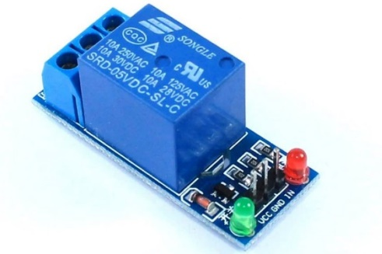

1. **PHOTOVOLTAIC CELL:**

The [photovoltaic effect](https://energyeducation.ca/encyclopedia/Photovoltaic_effect) is a process that generates [voltage](https://energyeducation.ca/encyclopedia/Voltage) or electric [current](https://energyeducation.ca/encyclopedia/Current) in a photovoltaic cell when it is exposed to [sunlight](https://energyeducation.ca/encyclopedia/Sunlight). These solar cells are composed of two different types of [semiconductors](https://energyeducation.ca/encyclopedia/Semiconductor)—a p-type and an n-type—that are joined together to create a p-n junction. By joining these two types of semiconductors, an [electric field](https://energyeducation.ca/encyclopedia/Electric_field) is formed in the region of the junction as [electrons](https://energyeducation.ca/encyclopedia/Electron) move to the positive p-side and [holes](https://energyeducation.ca/encyclopedia/Electron_hole) move to the negative n-side. This field causes negatively charged particles to move in one direction and positively charged particles in the other direction.

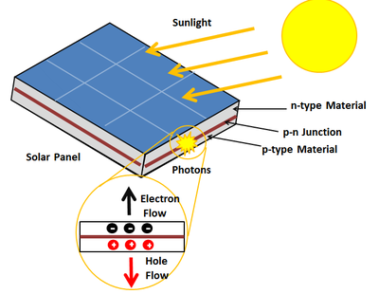 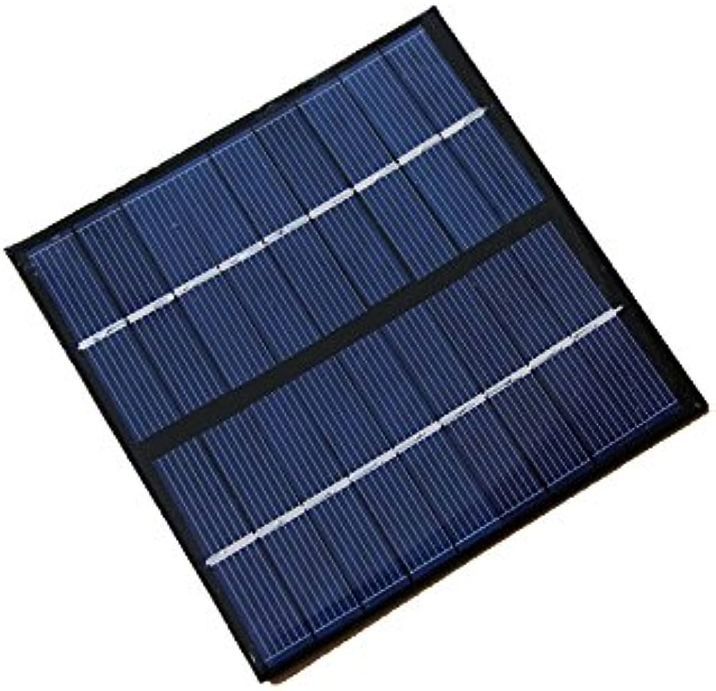

1. **12v BATTERY:**

A lead acid battery consists of a negative electrode made of spongy or porous lead. The lead is porous to facilitate the formation and dissolution of lead. The positive electrode consists of lead oxide. Both electrodes are immersed in a electrolytic solution of sulfuric acid and water. In case the electrodes come into contact with each other through physical movement of the battery or through changes in thickness of the electrodes, an electrically insulating, but chemically permeable membrane separates the two electrodes. This membrane also prevents electrical shorting through the electrolyte. Lead acid batteries store energy by the reversible chemical reaction

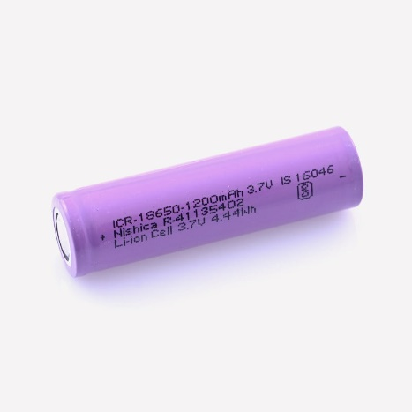

1. **LCD DISPLAY:**

**Liquid crystal display**

LCD (Liquid Crystal Display) screen is an electronic display module and find a wide range of applications. A 16x2 LCD display is very basic module and is very commonly used in various devices and circuits. These modules are preferred over [seven segments](http://www.engineersgarage.com/content/seven-segment-display) and other multi segment [LED](http://www.engineersgarage.com/content/led)s. The reasons being: LCDs are economical; easily programmable; have no limitation of displaying special & even [custom characters](http://www.engineersgarage.com/microcontroller/8051projects/create-custom-characters-LCD-AT89C51) (unlike in seven segments), [animations](http://www.engineersgarage.com/microcontroller/8051projects/display-custom-animations-LCD-AT89C51) and so on.

A **16x2 LCD** means it can display 16 characters per line and there are 2 such lines. In this LCD each character is displayed in 5x7 pixel matrix. This LCD has two registers, namely, Command and Data.

The command register stores the command instructions given to the LCD. A command is an instruction given to LCD to do a predefined task like initializing it, clearing its screen, setting the cursor position, controlling display etc. The data register stores the data to be displayed on the LCD. The data is the ASCII value of the character to be displayed on the LCD. Click to learn more about internal structure of a [LCD](http://www.engineersgarage.com/insight/how-lcd-works).

**LCD Pin Diagram:**

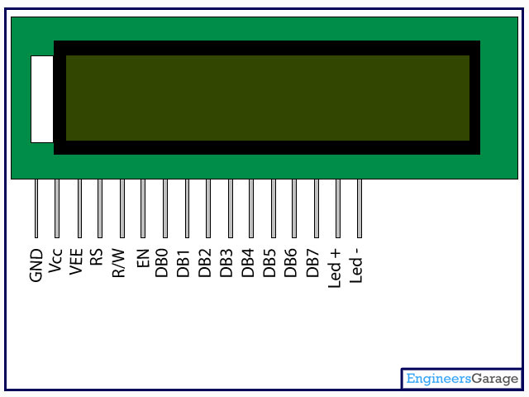

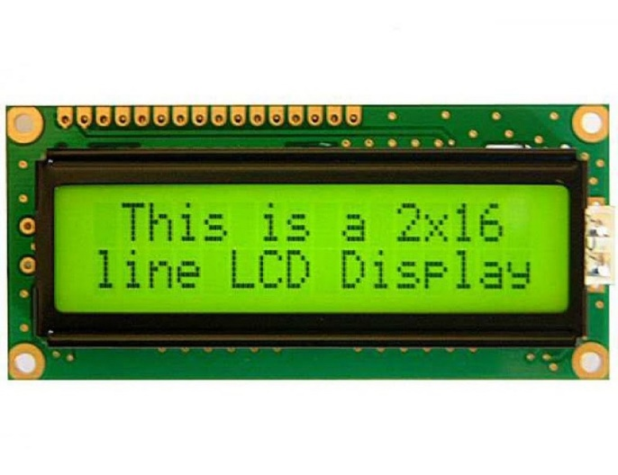

1. **PELTIER MODULE:**

Peltier plate used here is used to provide both heating as well as cooling effect according to need. Thermoelectric cooling uses the Peltier effect to create a heat flux between the junctions of two different types of materials. The principle of operations of the Peltier module is based on the Peltier effect which consists of heat energy transfer in response to the applied voltage. Thermal energy flows between two sides of the module: cold and hot. Consequently, the module absorbs heat from an element (e.g. LED) touching the cold side and gives it away to another element in the system (e.g. radiator) which is in contact with the hot side. The configuration of a single-stage Peltier module is shown below figure.

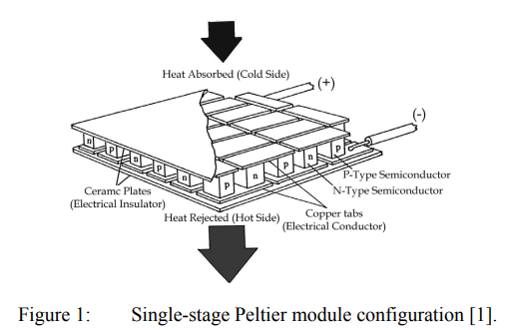

Single Peltier Module Configuration

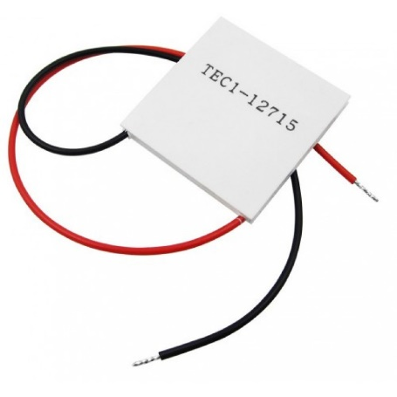

# TEMPERATURE SENSOR:

The DS18B20 digital thermometer provides 9-bit to 12-bit Celsius temperature measurements and has an alarm function with nonvolatile user-programmable upper and lower trigger points. The DS18B20 communicates over a 1-Wire bus that by definition requires only one data line (and ground) for communication with a central microprocessor. In addition, the DS18B20 can derive power directly from the data line (“parasite power”), eliminating the need for an external power supply. Each DS18B20 has a unique 64-bit serial code, which allows multiple DS18B20s to function on the same 1-Wire bus. Thus, it is simple to use one microprocessor to control many DS18B20s distributed over a large area.

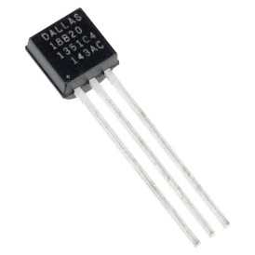

# CHAPTER 3

## CIRCUIT DIAGRAM

## 

**Circuit of the project**

**3.2** WORKING OF THE PROJECT

The working of the Smart Heating Combat Jacket could be explained in the following steps:

1. **Temperature Sensing:** The DS18B20 temperature sensor is strategically placed within the jacket to measure the wearer's body temperature accurately. We can also use alternative temperature sensors like TC47C, LM35 or DHT22 for basic temperature measurement. However, these temperatures are used to measure the soldier body temperature and therefore giving a signal to the microcontroller. It communicates this temperature data to the Arduino.
2. **Arduino Control:** The Arduino microcontroller receives temperature data from the sensor and processes it. It then determines whether the wearer needs heating or cooling based on a preset temperature threshold or user input. **The signal is driven to Arduino if the temperature exceeds the threshold, which is 55 degrees, and the jacket cools the Peltier module there as a result. In a different case, the jacket is warmed by heating the Peltier module with Arduino if the temperature is below the threshold value, which is 35 degrees.** To convert the analog temperature sensor data to a digital step size that is based on resolution, we execute analog to digital conversion (ADC) in the Arduino code.
3. **Heating Element:** When heating is required, the Arduino sends a signal to control the Peltier modules. Peltier modules are solid-state heat pumps that can both heat and cool surfaces depending on the direction of the electrical current. In this case, they are set to heat mode. In order to deliver targeted heating, the Peltier modules are carefully positioned within the jacket. We completely install 6 Peltier modules because this is a sufficient amount for us to detect the presence of a heat-related change. However, the soldier would feel comfortable for the difference in temperature because of the chilly weather when wearing these jackets.
4. **Battery and 5V Regulator:** The battery provides power to both the Arduino and the Peltier modules. The 5V regulator ensures a stable voltage supply to the Arduino. The voltage regulator 7805, which reduces any input voltage to 5 volts, is responsible for the regulated voltage. This guarantees that the Arduino is entirely secure and that the soldier should not be concerned about the power source.
5. **MOSFET Control:** MOSFETs act as electronic switches to control the power supply to the Peltier modules. The Arduino controls these MOSFETs to turn the Peltier modules on or off based on the temperature data. MOSFET control in the Smart Heating Combat Jacket serves as a vital mechanism for managing the power supplied to the Peltier modules, allowing precise and dynamic control of the heating elements. By adjusting the gate voltage, the Arduino can switch the MOSFETs on and off and implement PWM to regulate the temperature within the jacket, ensuring the wearer's comfort and energy efficiency.
6. **User Interface:** The LCD display provides a user interface, showing the current temperature, heating status, and any user settings or adjustments. Users can input their desired temperature settings through buttons or a touchscreen interface if included.
7. **Temperature Regulation:** The Arduino continuously monitors the wearer's temperature and adjusts the power supplied to the Peltier modules accordingly. This ensures that the wearer remains at a comfortable and consistent temperature.
8. **Power Management:** The system is designed to optimize power usage to extend the battery life. The **solar power** is implemented to recharge the batteries timely and it is the most efficient way to do so.

# CHAPTER 4

### 4.1 FUTURE SCOPE

The future scope of a Solar Powered Smart Jacket is promising, as it combines renewable energy technology with wearable electronics to provide practical and sustainable solutions for various applications. Here are some potential areas of growth and development for this innovative concept:

1. **Energy Efficiency and Sustainability:** As renewable energy sources become increasingly important in combating climate change, solar-powered wearable technology like the Smart Jacket could contribute to reducing reliance on fossil fuels. Enhancements in solar cell efficiency and energy storage could lead to longer-lasting and more self-sustaining wearable devices.
2. **Outdoor Activities and Sports:** Solar Powered Smart Jackets could find a significant market in outdoor enthusiasts and athletes. These jackets could power integrated LED lights, phone charging ports, GPS trackers, and other smart features, making them ideal for hiking, camping, cycling, and other activities.
3. **Urban Commuting:** With the rise of urbanization, people are looking for sustainable and efficient modes of transportation. Solar Powered Smart Jackets could be designed for urban commuters, providing features such as integrated solar panels that charge devices like smartphones while on the go.
4. **Emergency and Disaster Response:** In emergency situations, access to power can be crucial. Solar Powered Smart Jackets could be equipped with emergency lights, distress signals, and communication devices that are powered by solar energy. This could be especially valuable during power outages or natural disasters.
5. **Health and Well-being:** The smart capabilities of the jacket could be extended to health monitoring and well-being applications. It could integrate sensors to monitor vital signs, UV exposure, and temperature, providing users with real-time feedback to optimize their health and safety.
6. **Fashion and Design Integration:** As technology advances, the integration of solar panels into clothing could become more seamless and aesthetically pleasing. Designers could explore creative ways to incorporate solar panels into the fabric of the jacket, making it both functional and stylish.
7. **Education and Awareness:** Solar Powered Smart Jackets could play a role in educating users about renewable energy and environmental conservation. Through interactive features and mobile apps, users could learn about solar energy, carbon footprint reduction, and ways to live a more sustainable lifestyle.
8. **Integration with IoT and AI:** The Smart Jacket could be part of the Internet of Things (IoT) ecosystem, interacting with other smart devices and systems. Artificial intelligence could be used to optimize energy usage, predict solar charging patterns, and provide personalized recommendations based on user behavior.
9. **Business and Employee Benefits:** In corporate environments, companies could provide Solar Powered Smart Jackets to their employees, promoting sustainable practices and reducing the need for indoor charging stations for electronic devices.
10. **Research and Development:** Continued research into flexible and lightweight solar panels, energy storage solutions, and conductive fabrics could lead to advancements that enhance the efficiency and functionality of Solar Powered Smart Jackets.

**4.2 CONCLUSION**

In conclusion, the Solar Powered Smart Jacket represents a compelling blend of renewable energy and wearable technology, poised to revolutionize multiple aspects of modern living. As we navigate towards a more sustainable future, this innovative concept holds great promise in areas ranging from outdoor recreation and urban commuting to emergency response and health monitoring. The fusion of solar panels with wearable design opens up avenues for creative integration, enhancing functionality without sacrificing aesthetics. Moreover, the Smart Jacket can serve as an educational tool, fostering awareness about renewable energy and environmental consciousness. By capitalizing on advancements in solar cell efficiency, energy storage, and IoT connectivity, these jackets are set to become indispensable companions, catering to diverse lifestyles and needs. As society continues to prioritize eco-friendly solutions, the Solar Powered Smart Jacket stands as a shining example of how technology can be harnessed to promote sustainability, improve daily lives, and contribute positively to our planet's well-being.

**REFERENCES:**

[1]. S. Rahmam, M. A. Khallat, and B. H. Chowdhury, “A discussion on the diversity in the applications of photovoltaic system,” IEEE Trans. Energy Conversion, vol. 3, pp. 738–746, Dec. 1988.

[2]. B. K. Bose, P. M. Szczesny, and R. L. Steigerwald, “Microcomputer control of a residential photovolatic power conditioning system,” IEEE Trans. Ind. Applicat., vol. IA21, pp. 1182–1191, Sept. 1985.

[3]. B. H. Cho and P. Huynh, “Design and analysis of microprocessor controlled peak power tracking system,” Proc. 27th IECEC, 1992, vol. 1, pp. 67–72.

[4]. Man Prakash Gupta, Min-Hee Sayer, Saibal Mukhopadhyay and Satish Kumar, “Ultrathin Thermo-electric Device for On Chip Peltier Cooling”, Vol. 1, NO. 9, pp. 1395-1405, 2011 IEEE.

[5]. Rasit Ahıska, Hayati Mamur, “A review: Thermo-electric generators in renewable energy”, International Journal of Renewable Energy Research” Hayati Mamur et al., Vol.4, No.1, 2014.